The July Course Venue Access Information
Newmarket Racecourse is committed to ensuring that our venues are an easy and enjoyable experience for all to visit. To achieve this, we work towards addressing more than the minimum required by the Equalities Act (2010) and aim to ensure universal access.

Booking Information
Tickets are available to purchase online or by telephone on 0344 5793010. If you would like to check that the venue can meet your specific access requirements, please look at our access information or contact our customer relations team who will be able to provide you with further information.
If you have any queries, please contact our Customer Relations Department on 01638 675 500 (Option 4) or email newmarket.boxoffice@thejockeyclub.co.uk. Please note our office hours are Monday to Friday 9 am to 5.30 pm.

Personal Assistant Tickets
At Newmarket Racecourse, we are committed to providing all customers with the opportunity to enjoy a wonderful experience with each visit. As such, should you require a personal assistant in order to visit the racecourse, you are entitled to apply for one complimentary admission ticket for a nominated individual. The Personal Assistant ticket is only valid once you have purchased a ticket for yourself.
The personal assistant must be able to provide you with appropriate assistance which might include:
- Assisting you in moving around the racecourse
- Helping you evacuate the racecourse in the event of an emergency
- Accompanying and/or assisting you in using the racecourse’s toilets
- Assisting you in purchasing refreshments and food or using other services
- Assisting you in your transport to and from the racecourse

You will need to purchase your entry ticket and then immediately apply for your personal assistant ticket by sending your order number and supporting documentation via email to newmarket.boxoffice@thejockeyclub.co.uk
To avoid disappointment please be prompt when supplying your documentation as if an event sells out, we would not be able to offer a free personal assistant ticket.

Standard Race Days: As it is the Newmarket Racecourses policy that all persons under the age of 18 must be accompanied at all times when on course, the Personal Assistant Admission Policy does not apply to persons aged 17 and under on our standard race meetings as under 18’s are admitted free of charge when accompanied by a responsible adult aged 18 and above.

Newmarket Nights: For our Newmarket Nights events as all persons regardless of age must have paid for a full priced entry ticket, in this event we would offer a PA ticket for these events once we have proof of eligibility for under 18’s who require a Personal Assistant. Please note that any person(s) under the age of 18, cannot be classed as a Personal Assistant for health and safety reasons. As stated above, your personal assistant is to be able to look after you around the course, and to assist you with purchasing food and drink, where person(s) under 18 would not be eligible to purchase from our bars or our betting partners. They must be able to care for you in case of emergency and evacuation.

It is important to note that Newmarket Racecourses do not recommend Newmarket Nights as being suitable for children under 18, if you do wish to bring them as part of your party, it is at your discretion, they can attend as long as they hold a valid ticket to gain entry (and must be the same ticket as the adult has) and there is a responsible adult of 18+. By purchasing a ticket for an under 18 you are agreeing to these terms as well as our full terms and conditions. For further information on our Newmarket Nights please see our Music FAQ.
www.thejockeyclub.co.uk/newmarket/visitor-info/live-music-faqs/
Please note that tickets purchased through Third Party Ticket Agents and not directly with the Jockey Club will not be included in our PA policy and will not be offered a PA Free ticket.

Eligibility
The eligibility criteria for complimentary personal assistant admission are regularly reviewed and the racecourse reserves the right to update them from time to time.
Currently, those who receive one of the following benefits are eligible to apply for a free personal assistant ticket:
- Disability Living Allowance (DLA)
- Attendance Allowance (AA)
- Personal Independence Payment (PIP)
- Armed Forces Independence Payment (AFIP)
Additionally, people who are Registered Blind are also eligible.
Please note that, in all cases, the racecourse reserves the right to nevertheless decline to accept an application or to request additional supporting documentation if, in the racecourse’s view and discretion, there is reasonable doubt that the applicant would be at a substantial disadvantage in attending without a personal assistant given the accessible facilities and services available at the racecourse.

Required Supporting Documentation
When applying for your complimentary personal assistant ticket the following supporting documentation will be required in respect of one of the benefits referred to above:
- A copy of the current awarding letter from DWP or statement confirming receipt of the
- Allowance.
- A copy of the current awarding letter confirming receipt of the Personal Independence
- Payment.
- A copy of the current awarding letter confirming receipt of the Attendance Allowance.
- A specialist personal letter from the hospital to confirm that the person is in receipt of support services.
Please note that a Blue Badge is not accepted as evidence of eligibility.

How To Apply
Applications (including all proof) are to be made in writing to the racecourse via newmarket.boxoffice@thejockeyclub.co.uk in advance of the event.
Unfortunately, we are not able to offer complimentary entry for personal assistants on the day of the event. Please apply at the time of booking your ticket.
If you require entry to our Accessible Platforms to view the concert, please do confirm at the time of booking your personal assistant. These areas have limited capacity and must be booked in advance as these areas are very popular and do reach capacity. Should we not be able to accommodate your request and you would not be able to enjoy the event unless you were on the viewing areas, we would offer you a refund. Entry to the platforms is with wristbands only collected from our Free Pass Office, if you do not have a wristband, you would not be permitted access to the platforms.

Collecting Personal Assistance Tickets
Premier and Grandstand and Paddock and Garden Enclosure personal assistant tickets will be at the Free Pass Office. This is adjacent to the Premier Entrance 2 on the July Course. Please make sure you and your personal assistant are both present when collecting the personal assistant ticket.
Please note our Personal Assistant Policy does not apply to customers with temporary impairments such as broken bones, healing wounds and women who are pregnant.

Transport:
The venue is situated outside the centre of Newmarket town and is accessible by all vehicle types with no restricted height access.
- Train: The nearest mainline train station Is Newmarket situated 2 miles approx. from the July Course.
- Outrider Coach Services: The Racecourse operates a subsided coach service travelling from the below location;
- Cambridge train station
- Royston train station (Car Park of platform 2)
- Ely (Market Street)
- Soham (High Street)
- Bury St Edmunds bus station (Stand 9.)
The Ely, Soham, Royston and Bury St Edmunds service only runs on feature days. The coach stop for the Outrider Coach Services is more than 150m away from the entrances.
- Free Newmarket Shuttle Bus: There is a free shuttle bus service that operates from Newmarket train station and the town centre to the racecourse at regular intervals. The drop off and collection point at the racecourse for this service within the White Car Park. The bus services are run by an external company and if you require any specific information as to access on each service, please contact Neals Travel 01638 780066.
- Taxi: The taxi drop off and pick up is situated outside the front of Premier 1 Entrance, this is at the front of the White Car Park. This location is 5m from Premier 1 entrance, 150m to Premier 2 entrance, 220m to Grandstand & Paddock Entrance and 320m to Garden Enclosure entrance (Approx.). The free shuttle bus is situated 80m further on from the taxi rank. Please note there is a golf buggy service available to transport customers with mobility issues in between the entrances.

Coach Parking
The coach park is located approximately 60m from the Grandstand & Paddock entrance. The ground surface is grass.

Golf Buggy
The Racecourse operates a golf buggy service in and around the Racecourse car parks to assist customers with mobility issues getting from their cars, coaches or taxi's to the entrances. To order this service please make yourselves known to the car parking marshals who will arrange for the golf buggy to meet you at an agreed location. The golf buggy service has no facilities to transport wheelchairs or mobility scooters.

Car Parking
We have designated blue badge parking areas in three of our car parks. If assistance is required, please contact one of our car parking attendants.
Annual badge holders parking and Premier 1 entrance is situated at the front of the white car park, there are blue badge holder parking bays situated at the front right of the car park, this area can only be reached by entering via Gate 2. The car park is an open area with a tarmac surface along one edge; some closely mown grass may need to be covered to access Premier 1 entrance. The level ground to the entrance from the car park makes it accessible for wheelchair users without assistance.
The second area for blue badge parking is located in the blue car park, opposite the Premier 2 entrance. This car park is accessible by passing through Gate 1. Blue badge parking bays are located along the front of the car park nearest to the entrances. It is a level area near Premier 2 entrance. Please note this car park is a grassed area and assistance will be required for wheelchair users. This car park is located nearby to the Free Pass Office.
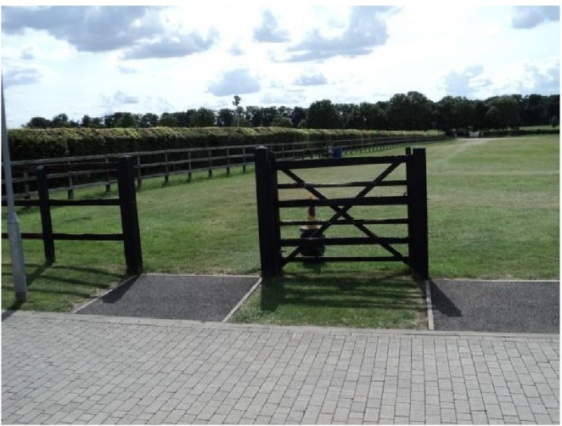
Garden and Grandstand & Paddock Enclosure parking is situated within the red car park, the blue badge holder parking bays are situated at the front of the car park along the fence line and are accessible through Gate 4 off the Cambridge road. The car park is an open area with a grass surface; it is accessible to a wheelchair user although assistance may be required as there are areas of grass to manoeuvre.

Grandstand & Paddock and Garden Enclosure Blue Badge parking

Premier Enclosure
Premier Entrance 2 has level access with a paved surface. The main doors are single width (90cm) and open automatically. There is a lowered operation window. These access points are situated on the left-hand side of the gate entrance. On race days there is a member of staff situated at the entrance to provide assistance.
Premier Entrance 1 has level access and has a tarmacked surface all the way from Premier Car Park. The main doors are double width (160cm) and open away from you (push). There is a lowered operation window at this entrance and on race days a member of staff will be stationed there to offer assistance. On passing through Premier Entrance 1, inside the venue there is horse crossing with a rubber surface which must be crossed.
The July Course is accessible for those with mobility issues including wheelchair users. There are paved and tarmacked routes covering the venue from the entrances to behind the grandstands. There is a hard standing paved pathway located in front of the Grandstands in the Premier Enclosure. Please note that the rest of the area racecourse side of the grandstand is fine turf. The area for the concert phase can become very congested with people standing to view the concert.

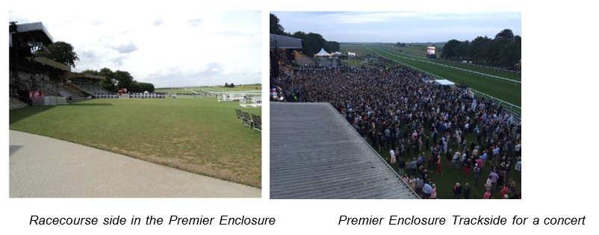
Accessible Lifts: Access lifts are located in stands 2 and 3 of the July Course. There is also a lift to provide access to the high-level walkway between the Dream Ahead bar and Mozart's Restaurant. The lifts are accessible through level access and are open to the public for use.
There is a maximum capacity of two people at one time (400kg). Each lift has a door width of 800cm and interior dimensions of 100cm x 130 cm (approx.).
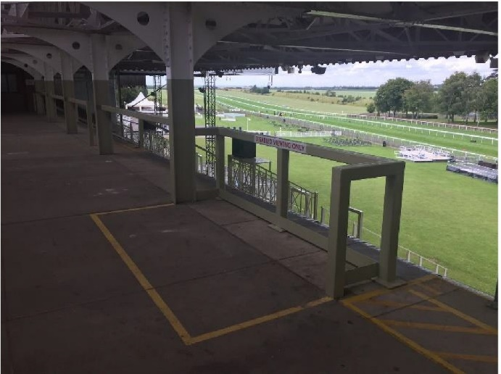
The lift in Premier Enclosure Stand 2 is located beside the Queens Room. This room is accessed on the right-hand side of Stand 2 (Winners Enclosure end) over a paved pathway. The lift can be used to access the accessible toilets on level 1 and the undercover viewing terrace on level 2 (Area E).

Viewing Area E from top of Stand 2 (Premier Enclosure)

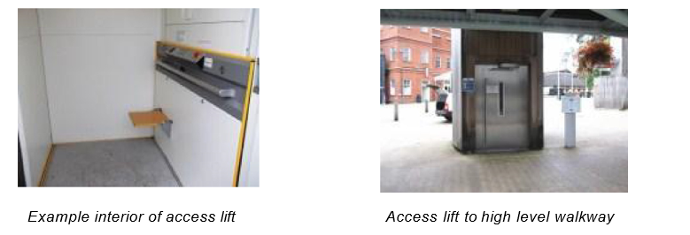
The lift to access the high-level walkway is located in the middle of the Premier Enclosure underneath the walkway. It can be used to access the Dream Ahead bar and Mozart’s Restaurant.

There is an accessible lift within Grandstand 3. To access this lift, there is a permanent downward slope located behind the grandstand to the left of the main entrance to the Adnams Southwell Bar. Once inside the access lift can be found on the right-hand side. This lift provides access to all levels of Stand 3, including the accessible toilet on the first floor, and the private boxes on level 2.
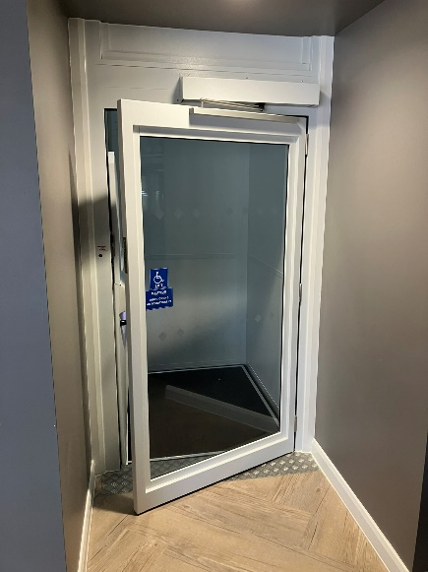
There is an accessible lift within the Champagne Bar located within the Premier Enclosure for access to the Rose Terrace.
The accessible lift located in the Champagne bar
All lifts operate by continuously holding your finger on the button of the floor required.

Accessible Toilets: All accessible toilets have clear signage near or on the appropriate doors. They are also highlighted on the site maps. In the case of any difficulty locating an accessible toilet please contact a member of staff. Each toilet includes wall mounted rails, a minimum lateral transfer space of 80cm, an emergency alarm pull cord and a drop-down rail. They all have twist locks on the door, a sink (no higher than 74cm) and a hand dryer (no higher than 100cm). The toilet seats are all situated 47cm above the floor with both the sink and toilet roll holder within arm's reach.
Premier Enclosure stand 2 has an accessible toilet located on the first floor; it is accessible from a lift on ground floor and there is level access throughout the route. The door to the toilet opens outwards (pull) with a width of 85cm. There is unobstructed manoeuvring space inside with dimensions of 150cm x 150cm.
Premier Enclosure stand 3 has an accessible toilet located on the first floor; it is accessible from a lift in the Adnams Southwold Bar, on the ground floor and there is level access throughout the route. The door to the toilet opens outwards (pull) with a width of 85cm. There is clear manoeuvring space inside with dimensions of 170cm x 200cm.
There are unisex accessible toilets located within the Champagne Bar for Premier Enclosure Customers only.
Viewing Platforms: There are a number of viewing platforms spread over the enclosures; there is limited capacity on each viewing platform and we work on a first come first serve basis. A booking system is in place for music events. The gradient of the ramps to access these platforms are no greater than 1:13.5. Chairs are available on request for personal assistants but this is dependent upon space available on the platform. There is also a covered viewing terrace at the top of Stand 2 for viewing racing and concerts (Area E).
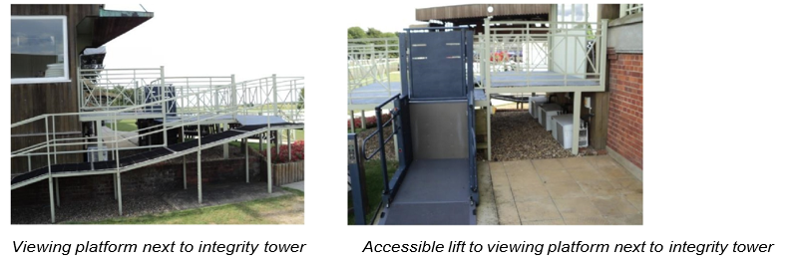
One platform is located in the Premier enclosure connected to the right hand side Stand 2 (Platform A). Access to the platform is from the rear of the grandstand, there is level access up to the slope which has a steep gradient. It is a permanent slope and assistance is on hand if required. Alternatively there is a platform lift available to access this platform. The platform lift is located at the front of the stand, with controls within reach for wheelchair users. This platform is suitable for viewing both the racing and a good side viewpoint for concert events. This platform also has a small undercover section.

A second platform is located in the Premier enclosure trackside in front of the Stand 2 (Platform B). Access to the platform is via a slope with a moderate gradient to the level platform.
A third platform in Premier enclosure is situated trackside in front of Stand 3 (Platform C). Access to the platform is via a slope with a moderate gradient to the level platform.
Access to both platforms above, involves travelling across a grass area and are open to the elements. Both of these platforms incorporate viewpoints for both racing and concert events. These ramps can become very congested for concert events. Please note that no alcoholic drinks are permitted trackside of Premier enclosure until all racing has finished.

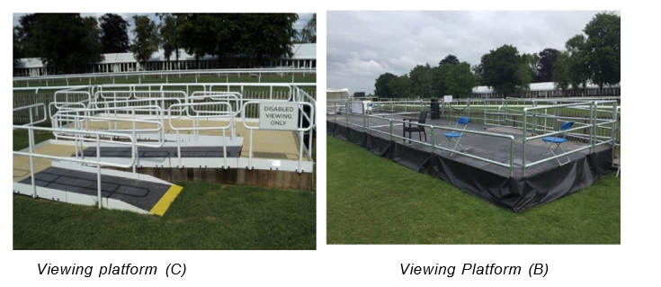
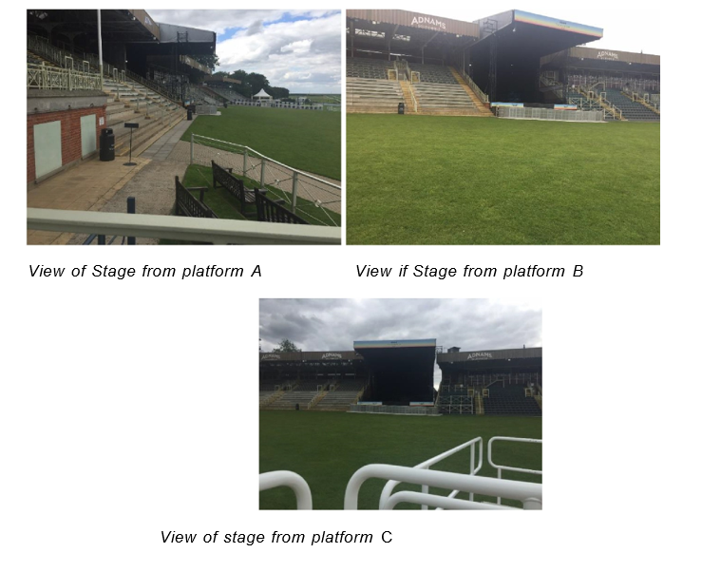
Music Nights: For music events access to the viewing platforms (A, Band C) is to be arranged in advance by contacting the Customer Relations Team on 01638 675500 (Opt 4). The booking system will be on a first come, first served basis. Passes to access each ramp will be issued when the personal assistance ticket is collected from the Free Pass Office, it is recommended to make your way to the viewing ramps in good time due the area becoming busy during concert phase. Family Enclosure customers who have pre booked these viewing platforms will be given access to move up before the penultimate race to ensure a clearer passage. Admission onto the platforms on the day without prior booking cannot be guaranteed.
The platforms can accommodate wheelchairs/scooters that are within the dimensions 700mm wide by 1200mm long. If a wheelchair/scooter is larger than these dimensions, this must be highlighted at the time of booking the platform place.
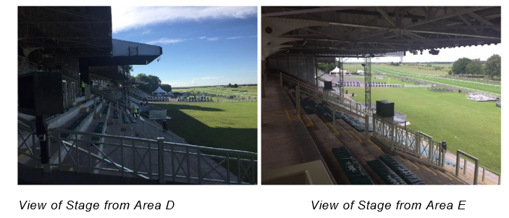
Customers with non-mobility issues can view the music in 2 reserved areas within the Grandstands. Spaces within these areas must be arranged in advance. Both areas can be accessed via a lift but there may be some steps that will have to be negotiated. Area D is located in the old stage area of Grandstand 2 and Area Eat the back of the stepping in Grandstand 2.

Spaces on the platforms and within the reserved areas include one visitor with one accompanying personal assistant. No other visitors can be accommodated on the platform/in the areas.
Please be aware that area D is only open from after last race i.e. concert only viewing. All other platforms and areas are open for the whole duration of the event.
Bars: The following bars have a lower-level trade counter: Adnams Southwold Bar, Chief Singer Bar, and Sweet Solara Bar. These service areas are clearly signed.

Grandstand & Paddock Enclosure
Grandstand and Paddock entrance has level access with a tarmacked surface. The entrance gate has a width of 90cm and an automatically opening barrier. This entrance overcomes the turnstiles and there is a lowered operation window. These access points are situated on the left hand side of the turnstile entrance. On race days there is a member of staff situated at the entrance to provide assistance.

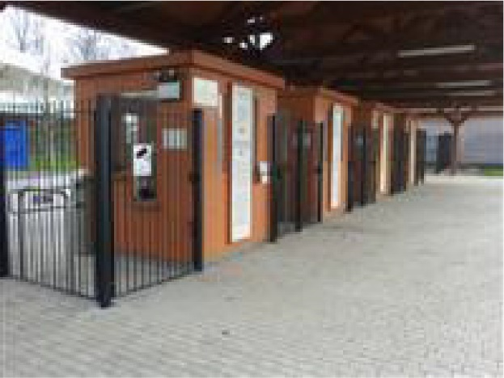
Grandstand & Paddock Enclosure entrance

In the Grandstand & Paddock Enclosure there is a tarmacked area in front of the Grandstand which accommodates the betting ring. Please note that the rest of the area racecourse side of the grandstand is grassed. The grassed areas are well maintained with short grass.
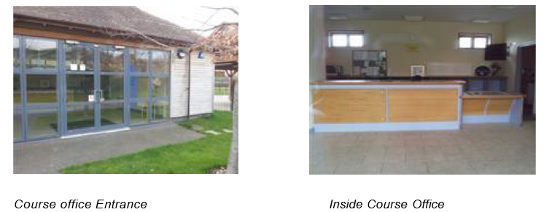
The course office/information point is located in the Grandstand & Paddock Enclosure, beside Premier Entrance 2. There is level access and a tarmacked surface around it. The main doors are double width (180cm) and open towards you (pull). On race days there is a member of staff stationed there to provide assistance. The reception desk is located 3m away from the main doors with level access on a tiled surface. The reception desk is at medium height with a lowered operation section to the right-hand end.

Accessible Toilets: There are three accessible toilets located around the perimeter of the Grandstand and Paddock enclosure. One is located next to the Soviet Star Bar, one opposite the Height of Fashion bar and another opposite the Royal Academy bar and next door to the Fish & Chip shop. All three accessible toilets have doors opening outwards (pull) with a width of 85cm. There is clear manoeuvring space in each one with minimum dimensions of 150cm x 200cm.
All accessible toilets in the Grandstand and Paddock enclosure are fitted with a RADAR (bow shaped) key lock system. If you do not hold a RADAR key these can be sourced in advance via this website - https://www.disabilityrightsuk.org/shop/radar-key.
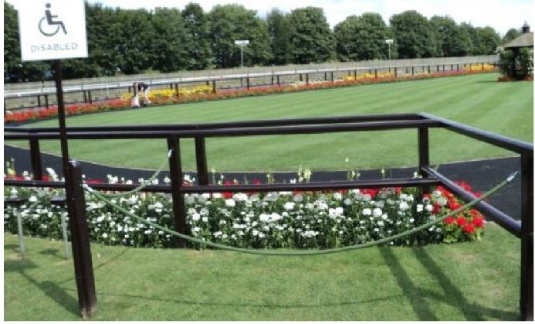
Parade Ring Viewing: For viewing the parade ring there is sectioned off area on the corner of parade ring side behind Stand 1 and next to the horse walk to the Winner's Enclosure.
Parade Ring Viewing Area
Viewing Platform: There are two concrete viewing platform within the Grandstand & Paddock Enclosure. Both platforms are trackside of Grandstand 4 and suitable for race viewing only.
Access is via a grass surface.
There is no viewing area within Grandstand 4.

Restaurants. bars, betting facilities: The following bars are equipped with lowered trade counters or have exit access for traders to offer service from ground level: Soviet Star, Royal Academy, Abernant Bar, Marwell Bar, Greenall's Height of Fashion Bar and the Owners & Trainers Bar.
All totes have a lowered counter or exit point to serve customers from ground level.
We apologise in advance that The Carroll House bar in Grandstand 4 is only accessible via a staircase as there is no lift available in Grandstand 4.

Garden Enclosure
The Garden Enclosure entrance is situated at the far end of the venue and all access is on level ground towards the entry gate. There are however some grass areas to navigate. The main doors are double width (150cm) and open towards you (pull).
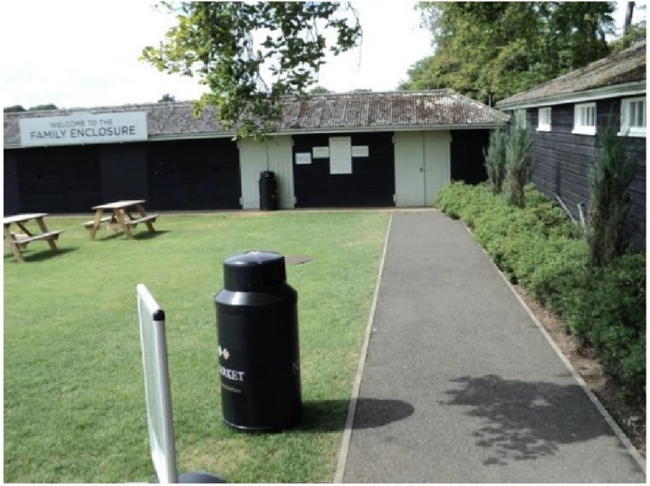

Garden Enclosure
Entrance

The Garden enclosure is mainly a grassed area. To spectate any of the racing customers must travel across grass and a gravel surface.

Accessible Toilets: The Garden Enclosure has an accessible toilet located in its toilet block. There is one toilet for female use and another for male use. Both of which have level access for entry. The door opens outwards (pull), and has a width of 85cm. The dimensions of the toilet are 150cm x 225cm allowing for manoeuvring space. Access to this toilet is level although a gravelled area needs to be passed over to get to the toilets. A temporary accessible toilet unit is in place within the enclosure for large sell out events.
Viewing Platform: There is a viewing platform within this enclosure which offers great views of the racing. The ramp is accessed via a grass surface.

Hospitality Guests
The following areas are hospitality areas: The Trackside Pavilions, The Grandstand 3 Private Boxes, The Paddock Pavilion, The Rose Terrace or the Summer House Restaurant.
The Trackside Pavilions consist of three hospitality marquees; Rous, Moorestyle and Empress Chalets. Blue badge parking is available behind the Trackside Pavilions for customers with hospitality in this area. This parking must be pre-arranged with the Hospitality Team. Access from the car park to the Pavilions is via blocked paved pathways, closely mown grass and tarmac. Each Pavilion is accessed via a small ramp or a set of steps. There is a dedicated accessible toilet in this area.
Good views of both the racing and concerts can be enjoyed from this area. The Trackside Pavilions is set across the course from the main Grandstands. Access to the parade ring and main enclosures is via crossing the racecourse with a medium grass length.
The Paddock Pavilion is accessed via closely mown grass and a ramped access. The Summer House Restaurant is the only dining facility that has air conditioning built in. This restaurant is accessed via a level door ledge. Both the Paddock Pavilion and Summerhouse Restaurant do not have a dedicated disabled toilet or racecourse viewing. Customers are to use the public disabled toilet by the Owners & Trainers bar - a radar key is required for this.
The Private Boxes in Grandstand 3 are accessed via an accessible lift.
The Rose Terrace can be accessed via the accessible lift located in the ground floor Champagne Bar, there is also an accessible toilet located in this area for Rose Terrace guests.

Mobility Scooters
Mobility scooters are welcome on site. Drivers of scooters must ensure they are capable and proficient in operating the scooter in a busy public environment. No mobility scooter should be left unattended with the keys in.

Involuntary Noise Issues
We welcome customers with involuntary noise issues or use noise to communicate rather than words. We are responsible for the enjoyment of the audience as a whole and therefore if disturbance is judged to be unreasonable for the nature of the event and prolonged, it may be necessary for us to ask you to take a break from largely populated areas. The venue does tend to be a lively and noisy area. Please speak to our Customer Relations Department if you require any additional services.

Assistance Dogs
Assistance dogs are welcome to attend with their owners without additional charge subject to production of a valid identity document from Assistance Dogs UK or an equivalent international organisation. A separate ticket is not required however owners should notify the racecourse in advance upon booking their event tickets so that any necessary arrangements can be made.
Assistance Dogs must be kept on leads at all times and we strongly encourage the use of an identifying harness to assist our teams in ensuring you are not challenged throughout the event.
A dog park is available on site and can be found using the What3Word reference: brass.include.dreading.

Personal Evacuation Plans
In the instance that a customer requires or would like to arrange a personal evacuation plan with the venues operations team, we would be very happy to help. Please contact our Customer relations department who will relay the information onto the staff on the day. Please note that all our staff are trained and aware of the appropriate measures to undertake in case of an incident.

Additional Information
- Staff do receive disability awareness/equality training.
- Plastic cups, cutlery and straws are available on request.
- No alcohol is permitted in the Premier enclosure Racecourse side until after the last race has finished as this area is an alcohol-free zone.
- No food and drink can be brought into the Premier Enclosure or Grandstand & Paddock Enclosures, please contact the below telephone number if an exception is required. No garden furniture or picnics are to be brought into the Premier and Grandstand and Paddock Enclosures at any time even for the live music performance.
- Limited food, drink and garden furniture is allowed to be brought into the Garden Enclosure – please see our full picnic policy here: https://www.thejockeyclub.co.uk/newmarket/plan-your-day/food-drink/picnics/
- Concert viewing is in the Premier Enclosure Racecourse side. Grandstand & Paddock Enclosure and Garden Enclosure customers are permitted access to the Premier Enclosure to view the concert after the last race. Access is opened up in a staged process.
- Space on the accessible viewing ramps for music events is via a booking system. Please contact the Customer Relations team for more details on how to book a space.

Contact Information
EmaiI: newmarket.boxoffice@thejockeyclub.co.uk
Telephone: 01638 675 500 Option 4

